from flask import Flask

# Create a Flask app

app = Flask(__name__)

# Define a route for the homepage

@app.route('/')

def home():

return “Ouriel Cohen!'

# Run the app

if __name__ == '__main__':

app.run(debug=True)

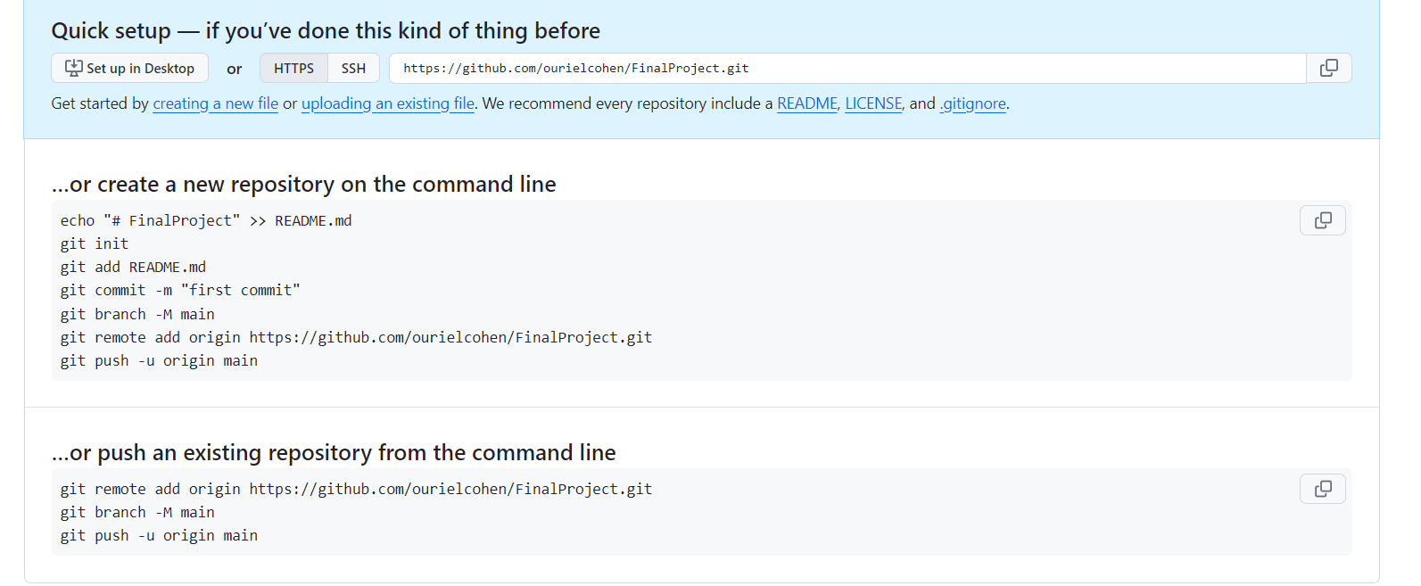

git config --global [ouriel.cohen@gmail.com](mailto:ouriel.cohen@gmail.com)

git config --global user.name "Ouriel Cohen"